BEAM DEFLECTION CALCULATOR

## Analyzes how Beams bend under loads

## Input: Beam length, Support type, Load types & Magnitude

## Output: Shear Force Diagram, Bending Movement, Deflection Curve

## Libraries: numpy, matplotlib, scipy

## Extensions: Add GUI using tkinter or Streanlit

# SOURCE CODE:

import matplotlib.pyplot as plt

class PointLoad:

    def __init__(self, magnitude, position):

        self.magnitude = magnitude

        self.position = position

class Beam:

    def __init__(self, length):

        self.length = length

        self.loads = []

    def add_point_load(self, magnitude, position):

        self.loads.append(PointLoad(magnitude, position))

    def calculate_reactions(self):

        """Assume simply supported beam with supports at x=0 and x=L"""

        total_load = sum(load.magnitude for load in self.loads)

        moment_about_A = sum(load.magnitude * load.position for load in self.loads)

        Rb = moment_about_A / self.length

        Ra = total_load - Rb

        return Ra, Rb

    def shear_force_distribution(self, step=0.01):

        Ra, Rb = self.calculate_reactions()

        x_vals = []

        shear_vals = []

        shear = Ra

        current_load_index = 0

        for x in frange(0, self.length, step):

            while (current_load_index < len(self.loads) and

                   abs(x - self.loads[current_load_index].position) < step / 2):

                shear -= self.loads[current_load_index].magnitude

                current_load_index += 1

            x_vals.append(x)

            shear_vals.append(shear)

        return x_vals, shear_vals

def frange(start, stop, step):

    """Range function that supports float stepping"""

    while start <= stop:

        yield round(start, 5)

        start += step

def plot_shear_force(x, shear):

    plt.figure(figsize=(10, 4))

    plt.plot(x, shear, label='Shear Force', color='blue')

    plt.axhline(0, color='black', linewidth=0.8)

    plt.xlabel("Beam Length (m)")

    plt.ylabel("Shear Force (N)")

    plt.title("Shear Force Diagram")

    plt.grid(True)

    plt.legend()

    plt.show()

beam = Beam(length=10)

beam.add_point_load(500, 2)

beam.add_point_load(1000, 5)

beam.add_point_load(750, 7)

x_vals, shear_vals = beam.shear_force_distribution()

plot_shear_force(x_vals, shear_vals)

## OUTPUT:

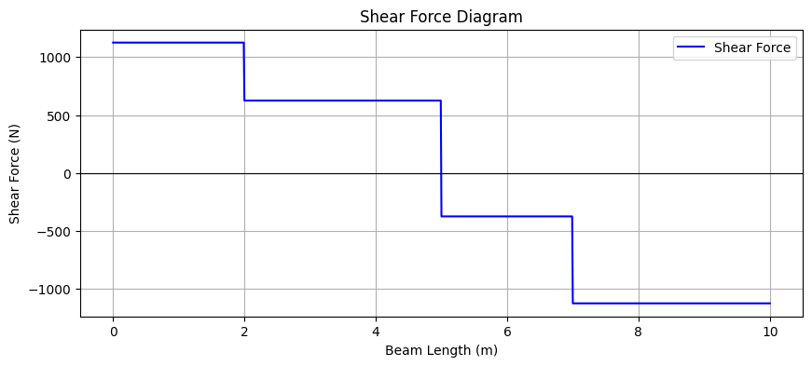

# CONCLUSION:

A **beam deflection calculator** is a valuable tool for structural engineers, architects, and students. It provides a quick and accurate method for determining the **deflection**, **shear force**, and **bending moment** in a beam under various loading conditions